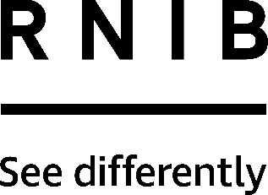

Bread Cutter Board (DK119)
Thank you for purchasing from RNIB. For hygiene reasons this product is non-returnable unless faulty, or it can be returned within 14 days if unsuitable, in an unopened and as new condition. If, unfortunately the item is unsuitable and it meets the unopened and as new criteria, please contact us within 14 days of receipt to obtain your returns number. For further details and guidance on returning faulty items, please see the Terms and conditions of sale and How to contact RNIB sections of this instruction manual.

Please retain these instructions for future reference. These instructions are also available in other formats.

General description
A practical bread cutting aid designed to help you cut straight and safely even if you have impaired vision or co-ordination difficulties. The board makes cutting simple and safe by holding the bread to be cut in a secure and stable position.

Orientation
This board has a rotating bar which is marked with raised dots, to determine the thickness of slices - one dot is the thinnest slice and four dots is the thickest. A knife (not supplied) is then inserted into the slicing guide.

Using the product
Rotate the bar to the required thickness and then push the bar down so it is flat against the board. Line up the bread against the bar. Insert a knife in between the guides and slice downwards.

This product is dishwasher safe.

How to contact RNIB
Phone: 0303 123 9999
Email: shop@rnib.org.uk
Address: RNIB, Midgate House, Midgate, Peterborough PE1 1TN
Online Shop: shop.rnib.org.uk

Email for international customers: exports@rnib.org.uk

Terms and conditions of sale
This product is guaranteed from manufacturing faults for 12 months from the date of purchase. If you have any issues with the product and you did not purchase directly from RNIB then please contact your retailer in the first instance.

For all returns and repairs contact RNIB first to get a returns authorisation number to help us deal efficiently with your product return.

You can request full terms and conditions from RNIB or view them online.

RNIB Enterprises Limited (with registered number 0887094) is a wholly owned trading subsidiary of the Royal National Institute of Blind People ("RNIB"), a charity registered in England and Wales (226227), Scotland (SCO39316) and Isle of Man (1109). RNIB Enterprises Limited covenants all of its taxable profits to RNIB.

Date: February 2019.

© 2019 Royal National Institute of Blind People.

